**CSCE 5290 - NLP - ICE1**

**Name:** Rafael Alves Moreira

**Group Members:**

Kevin Raj

Robert Linhart

Alejandro Munoz

1. Why we use stopwords? Why stopwords are not necessary for NLP frequency distribution.
   1. We use stopwords to give proper meaning and context to a sentence.
   2. Stopwords are not necessary for NLP frequency distribution because it likely won’t capture the main subject of the text, since stopwords appear more frequently.
2. Based on high frequency words what information you can extract from the graph?
   1. From the graph with stopwords, very little was able to indicate what SpaceX is involved with.
   2. From the graph without stopwords, I was able to gather that SpaceX was going to launch, where it was going (Space), and possibly the months (May or March)

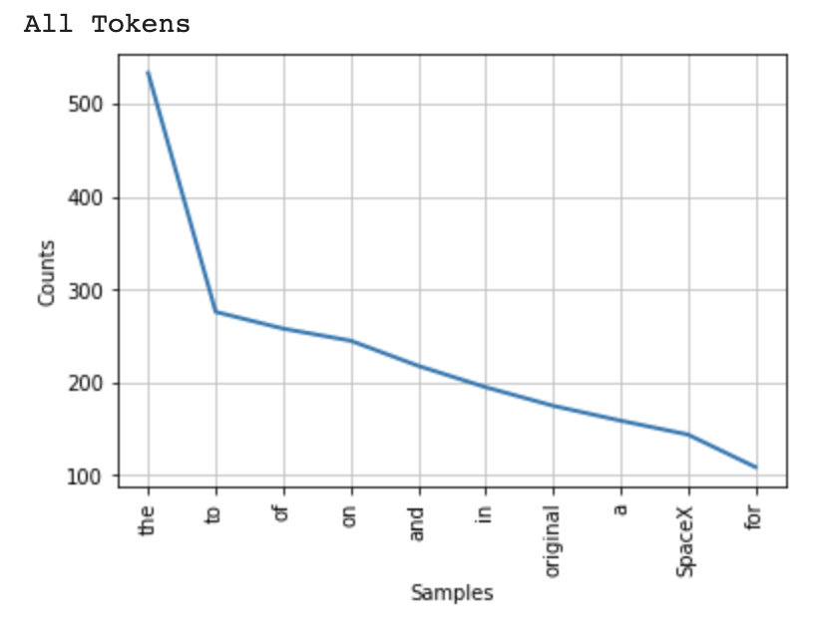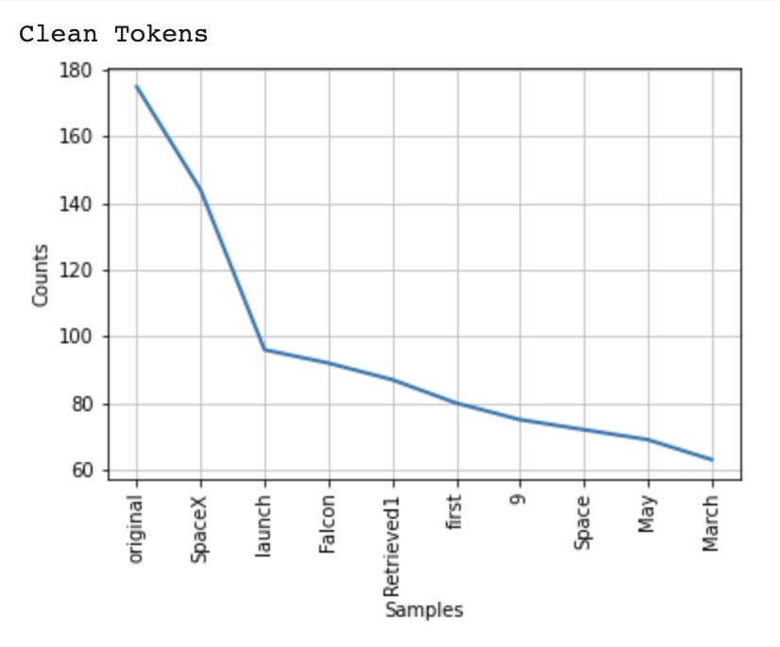

1. Can you provide different visualization for frequency distribution? If yes, please perform. If no, why?
   1. Yes, we can tabulate the sample distribution.

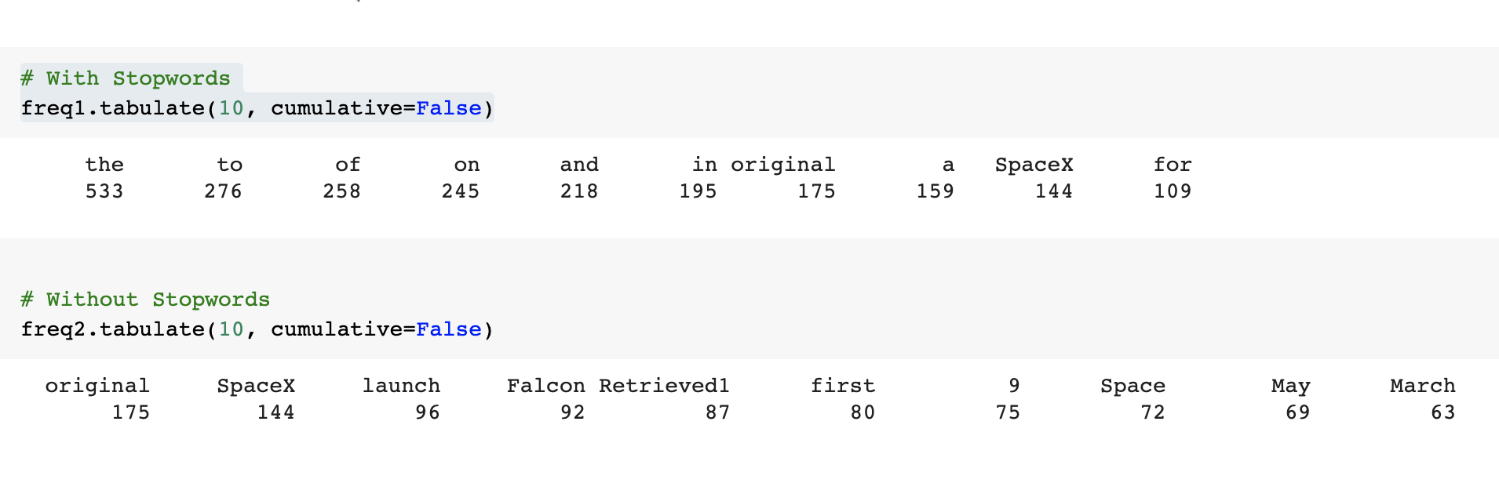

Link to github: <https://github.com/rmoreira/NLP>

Link to Wiki: <https://github.com/rmoreira/NLP/wiki>

Link to assignment: <https://github.com/rmoreira/NLP/tree/main/ICE-1>